- What are the custom are the custom actions that we can do while creating a bean ?

Why do we need custom actoin lets say we want to intialze the db connection right before the bean is created and we want to remove the db connection right after the bean is destroy at these cases these custom actions is very useful.
- Perform action before bean creation
- Perform action after bean destory
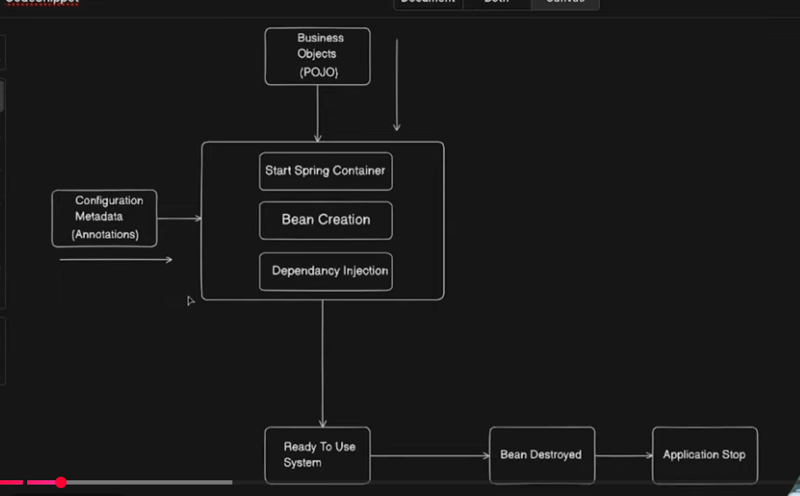
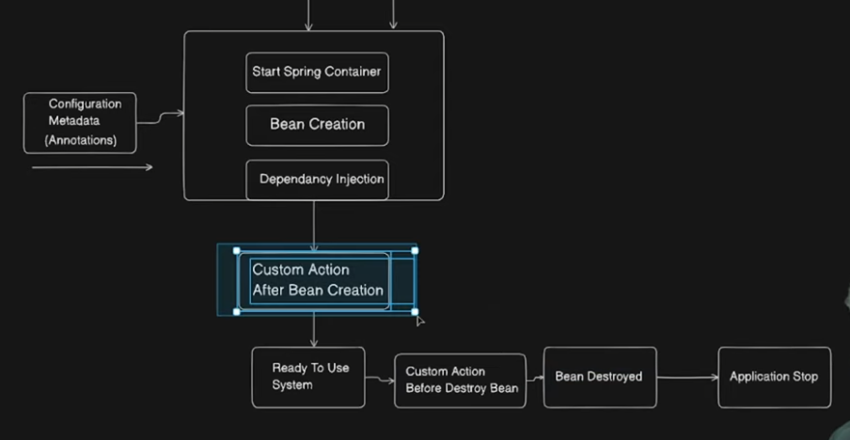
2)There are two ways to customize the bean life cycle
- Using interfaces IntiatlizingBean,DisposableBean
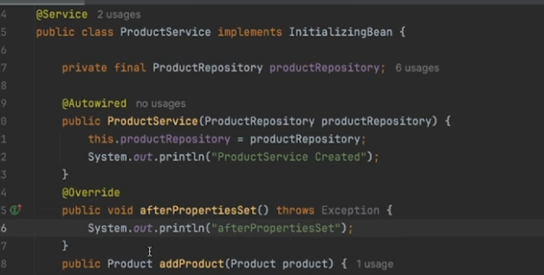
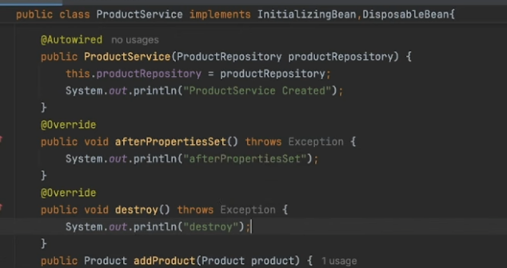
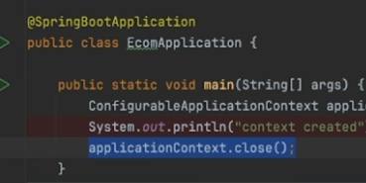
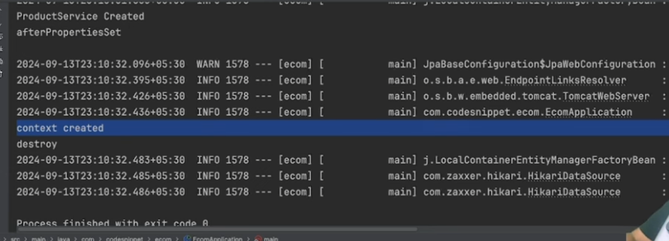

- @PostConstruct and @PreDestroy


